**API Automation Testing (Rest Assured)**

Rest Assured is and API through which we automate Rest API.

We can also have called it as Library.

**Pre-Requisite:**

Java 9+ /eclipse 🡪 supported

TestNG (To check either it is installed or not. Go to window 🡪 preferences 🡪 see (TestNG)

Maven (Comes with Eclipse)

Workspace: is space where we store our data

------------------------------------------------------------------------------------------------------------------

Created Maven project automatically create jar files and libraries.

We can easily remove the old jar files and libraries when changes are made.

--------------------------------------------------------------------------------------------------------

**TestNG Plugin**

Eclipse 🡪 help 🡪 eclipse marketplace 🡪 search what plugin you need

Create simple project instead of **JavaProject,** later on convert it into maven project

In Maven Project: **GroupId (Project Name), ArtifactsID (Packages etc). Both Name can be same**

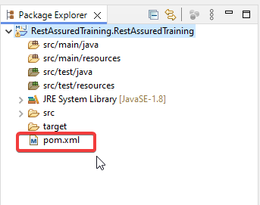

**(.xml) file is imp file where all dependencies are available. And we can also add dependencies here.**

Change text size and color etc then simply **window** 🡪 **preferences🡪General 🡪 appearance**

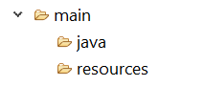

This is for development once the development end then testing start from

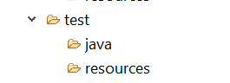

Add dependencies on **pom.xml file.**

Dependencies required for **rest assured**

<https://rest-assured.io/>

syntax:

<dependencies> </dependencies>

**Set Environment**

**Add all dependencies in .xml file**

Rest-assured.io

Json-path

Json

Gson

testng

Scribejava-apis

Json-schema-validator

Xml-schema-validator

--------------------------------------------------------------------------

To access all these dependencies, go to <https://mvnrepository.com/>

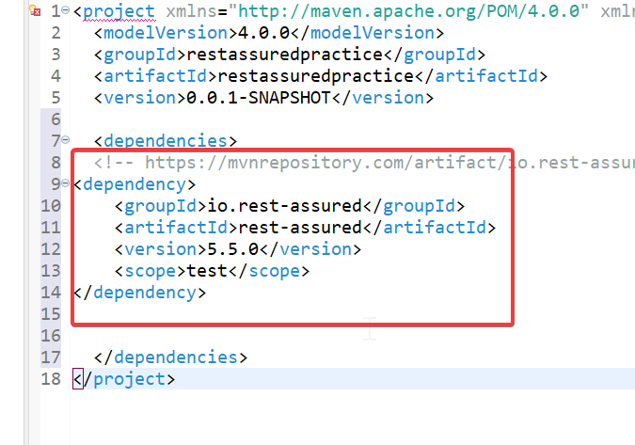

This is how we can add dependencies.

Simply change the version here it automatically update the version.

**Implementation:**

**Different Request Comes under RestAssured:**

**http request**

Get

Post

Put

Delete

**For Practice (reqres.in)**

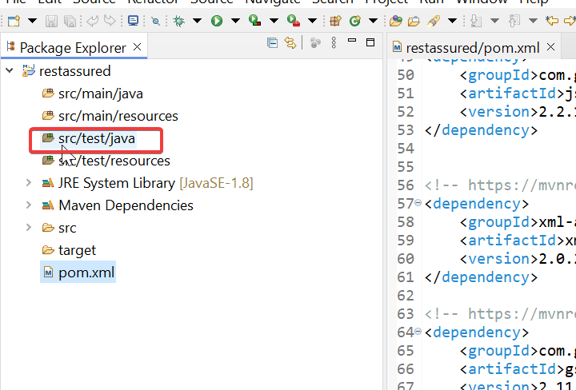

Here we perform testing

We don’t need for main (development) directory so we can also delete them

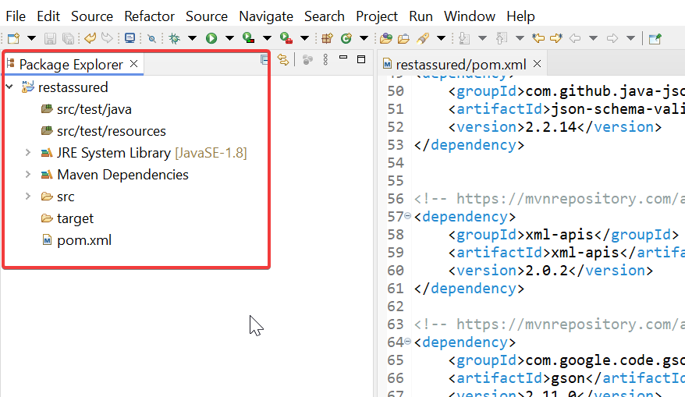

Create New Package 🡪 then New Java Class (which is our Test case)

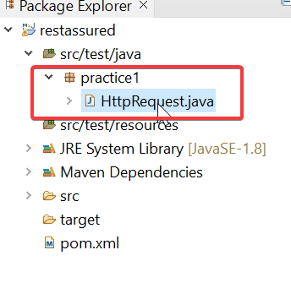

**How to Write Test Cases while using RestAssured (in Java)**

We use BDD Approach.

Gerkin🡪 keyword (which are used in This approach)

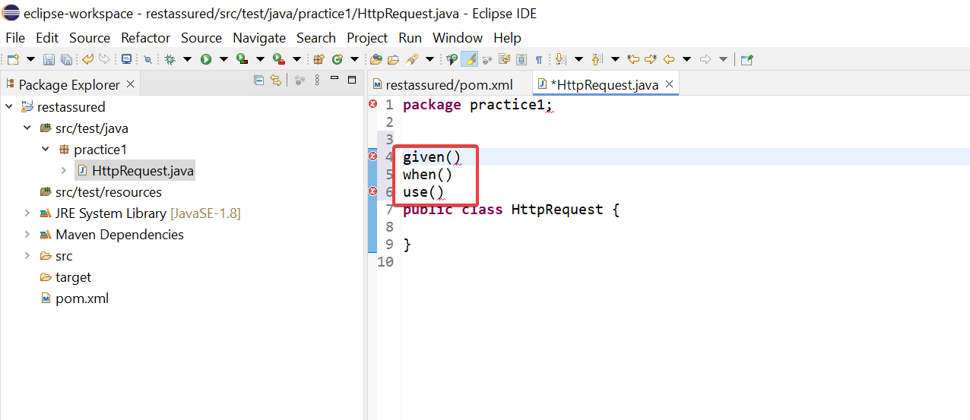

These three methods must use before writing the testcases

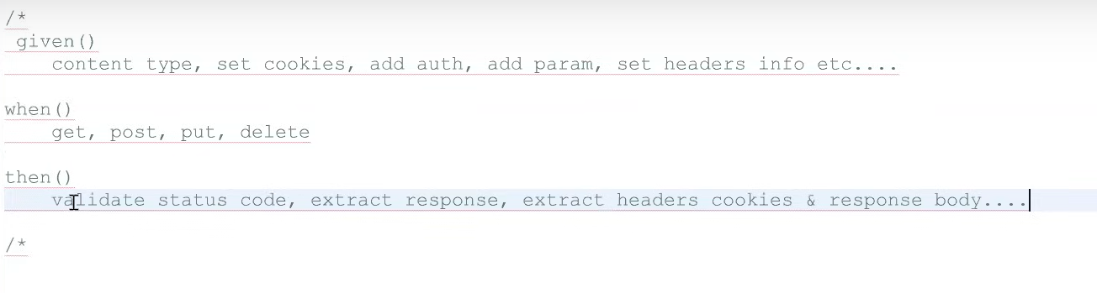

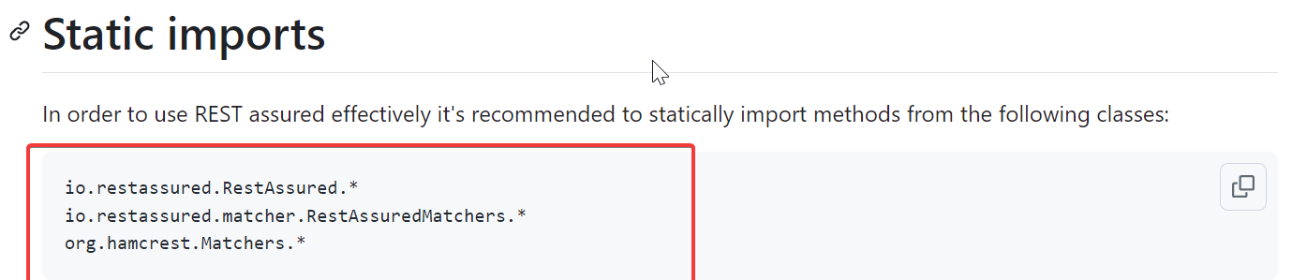

These packages import for using these methods.

Given method is optional (don’t necessary to add these)

Provide complete path of request

**Suppose I am taking request link from reqres.io website so the link will be**

**Get User (Get Request)**

<https://reqres.in/api/users/2>

**Post User 🡪 create User (Post Request)**

<https://reqres.in/api/users>

Body for creation:

{

"name": "morpheus",

"job": "leader"

}

Same for the Put (Update Changes) and delete.

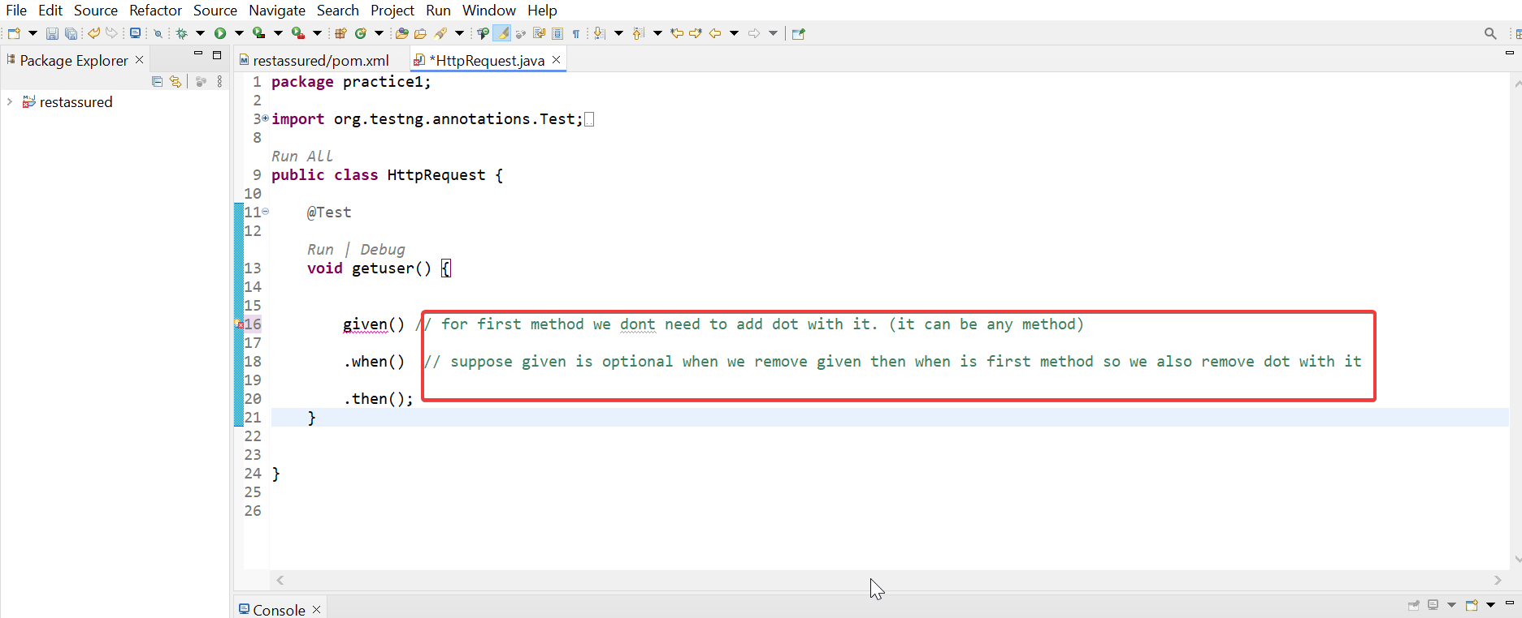

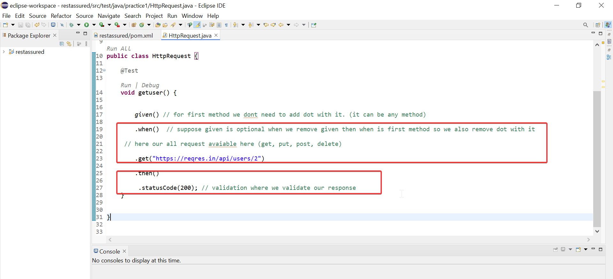

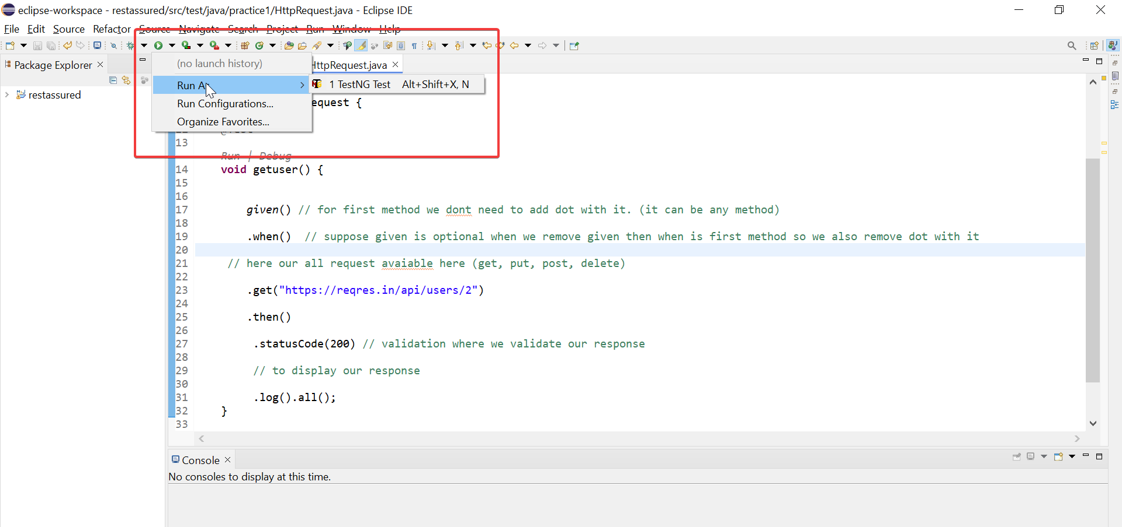

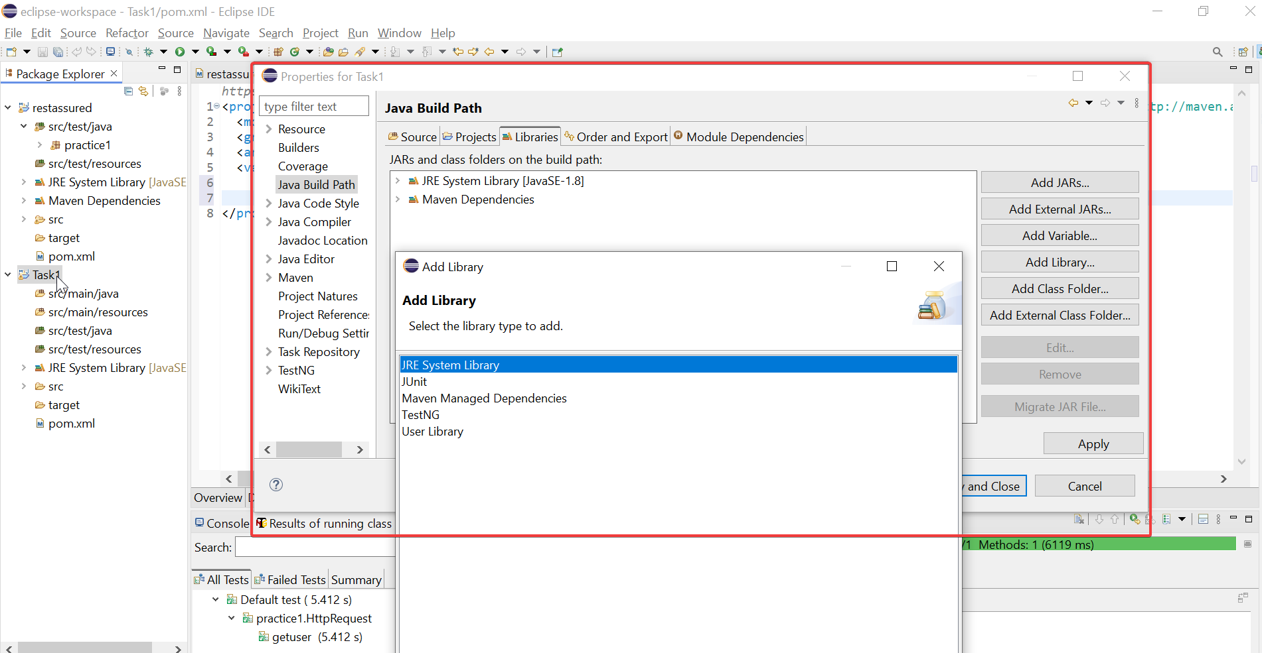

We can also add TestNg library in here in case if we don’t add it in pom.xml (dependencies)

**Real Implementation:**

* Create Maven Project
* Add Dependencies (that are pre-req) in pom.xml file
* Then create package under test class and then add new Java class
* Import pre-req library and then work on it.

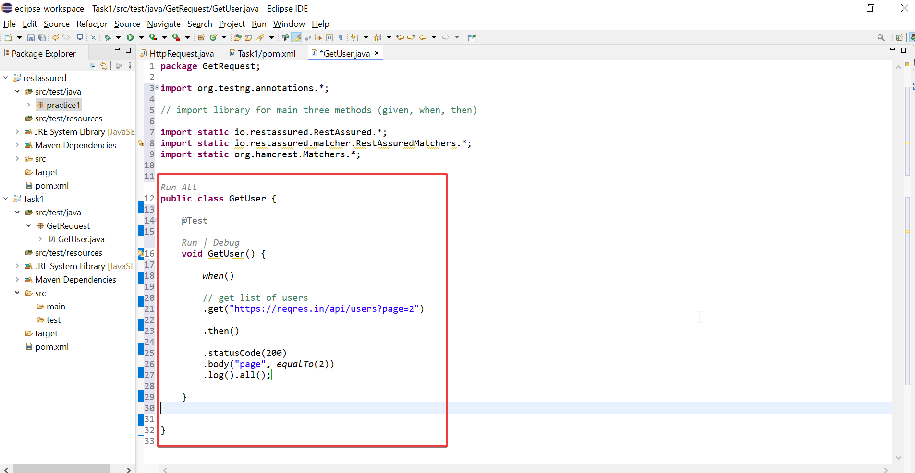

Post user Request:

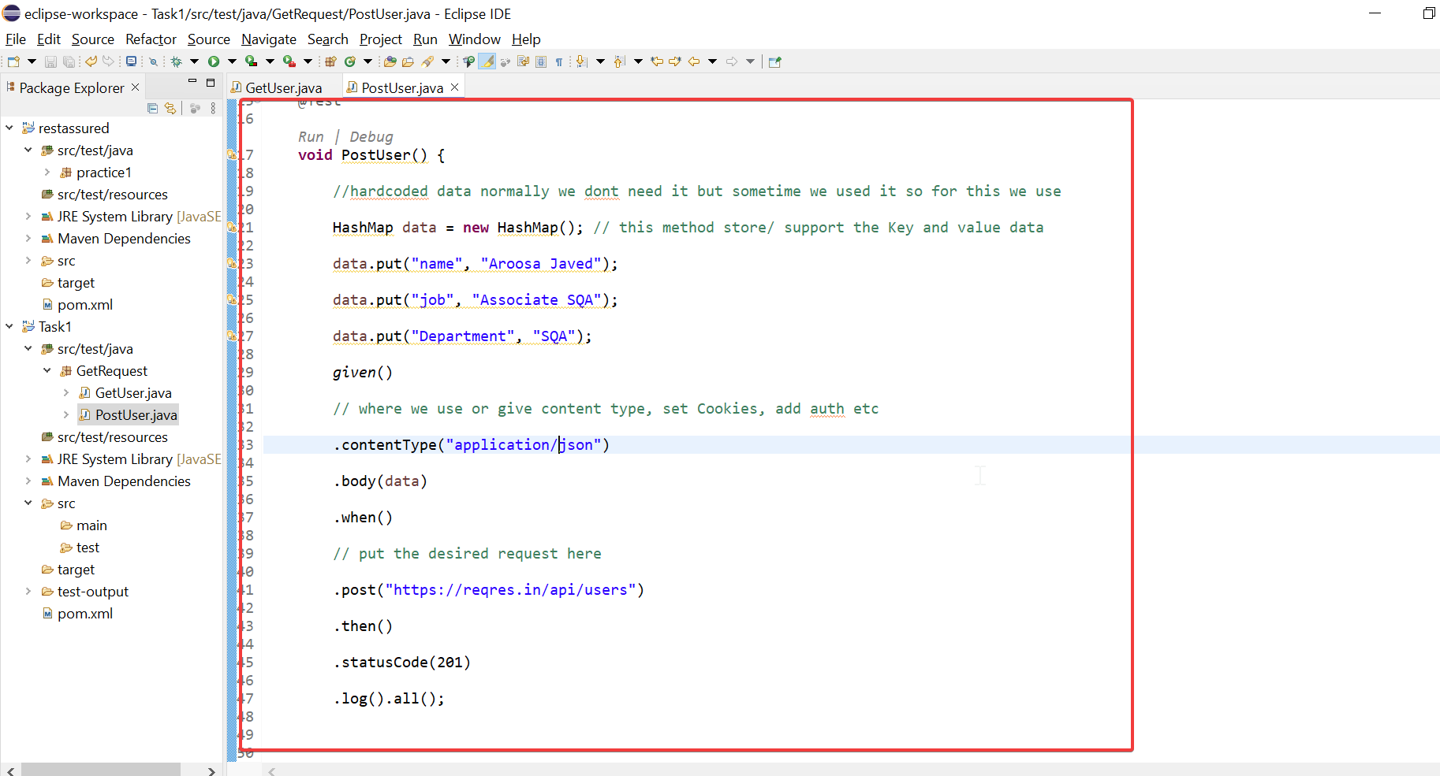

Update Request:

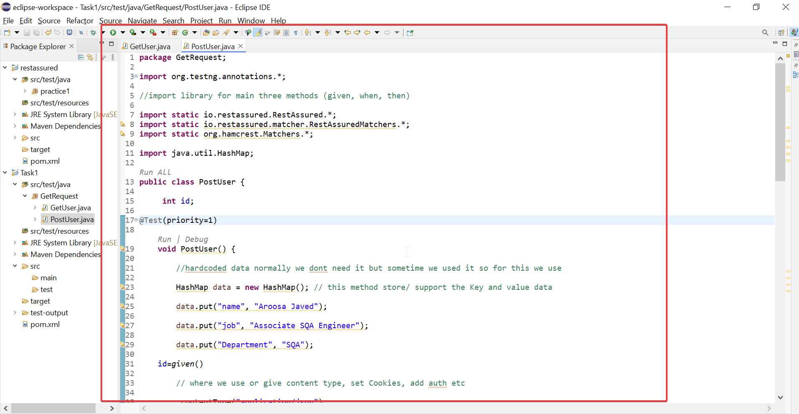

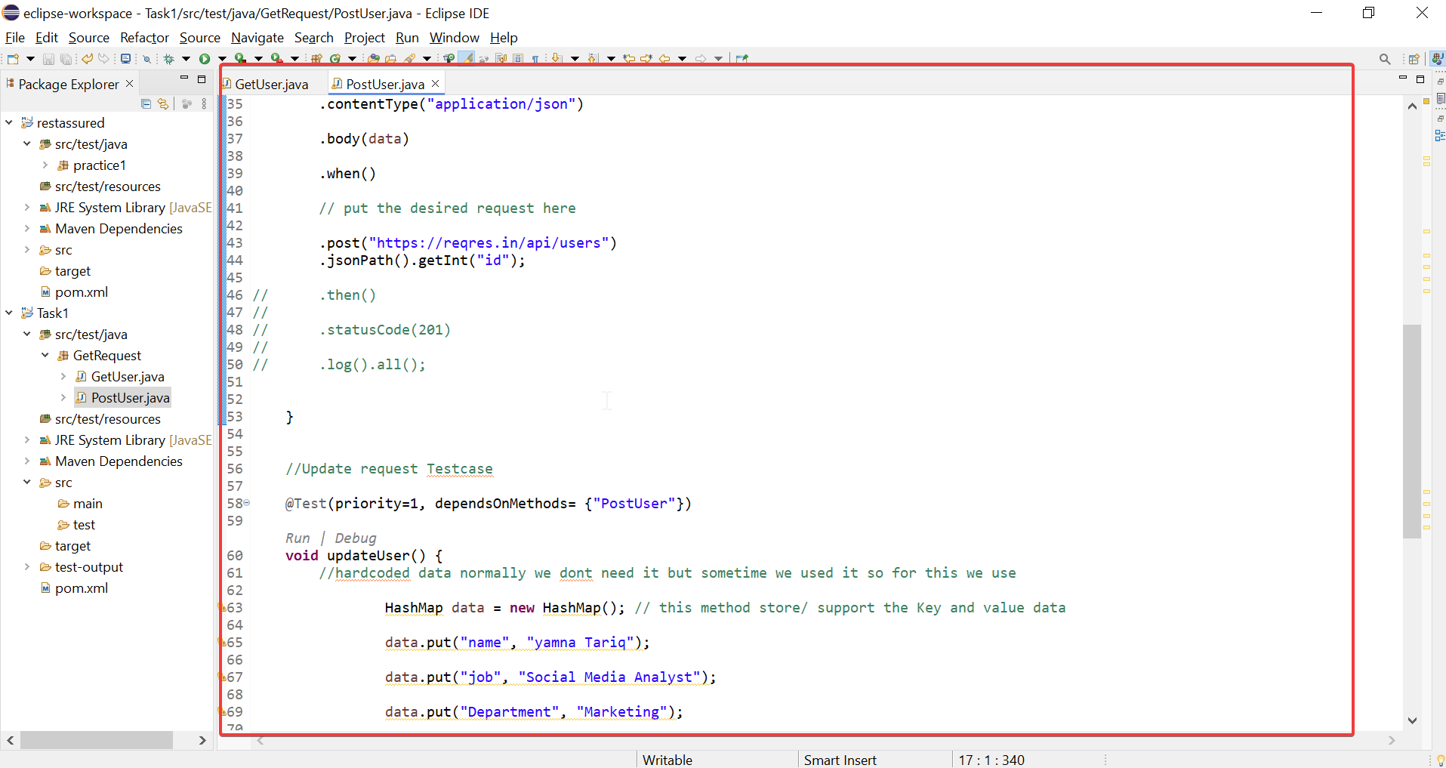

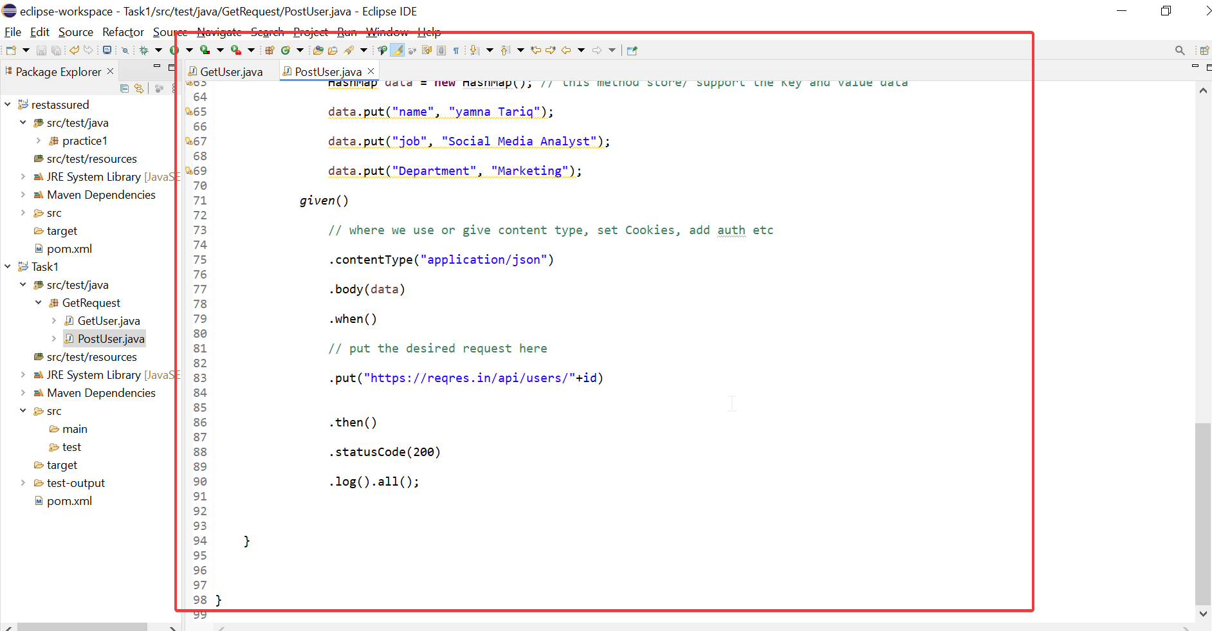

Delete Request:

